# **Create a GitHub Account and Repository**

# Create a GitHub Account

Go to <https://www.github.com> and enter your username, email, and password, and click “Sign up for GitHub.”

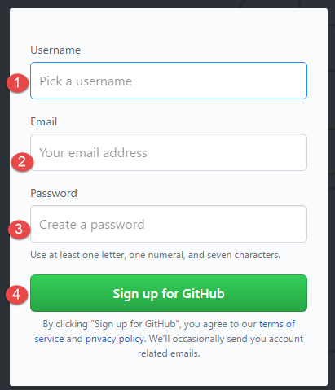

After you’ve logged in, follow the next steps to get the GitHub Education Pack. *Note: It may take 48-72 hours for the verification process, but you’ll still be able to use GitHub, as well as complete your assignments.*

# Get the GitHub Education Pack

Visit <https://education.github.com/pack> and click on “Get your pack”.

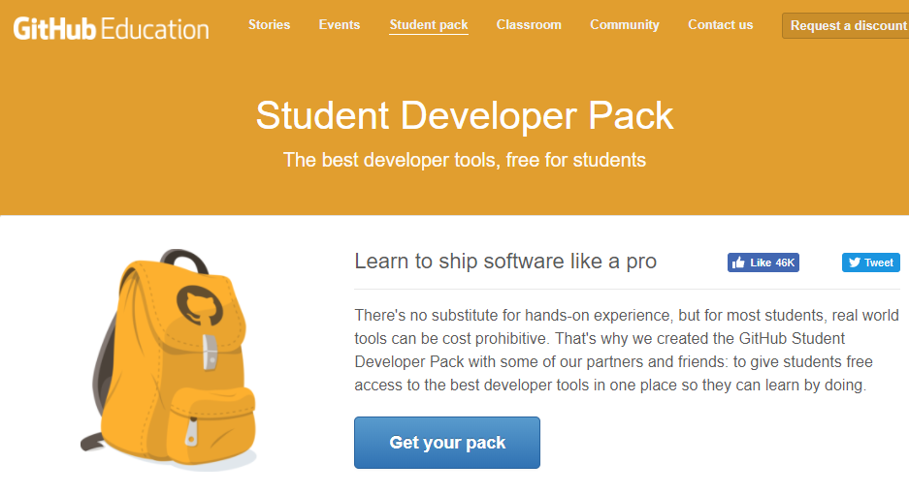

Click on “Yes, I’m a student.”

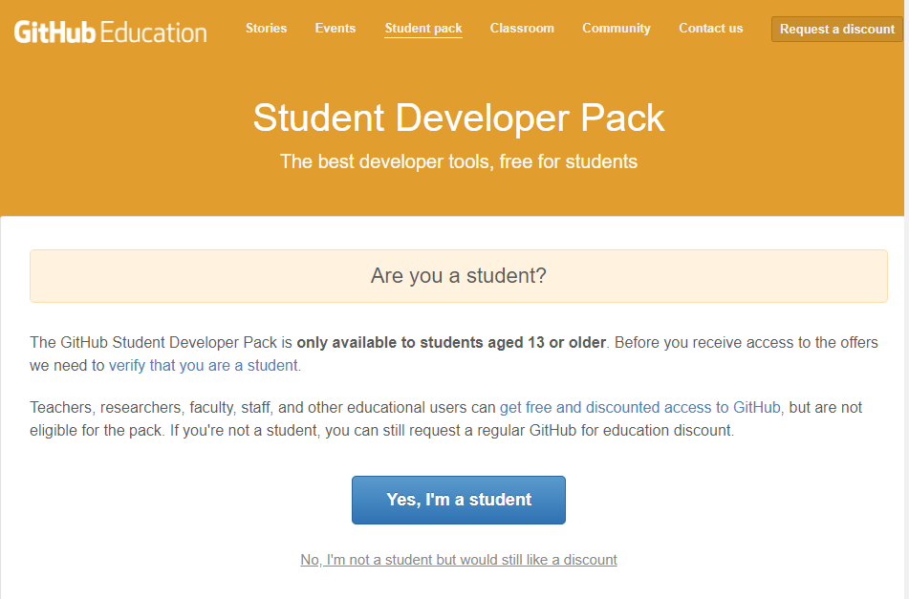

Enter your GitHub username, Rasmussen issued email address, School name, Graduation year, and describe how you’ll use GitHub for this course. Then click Submit request.

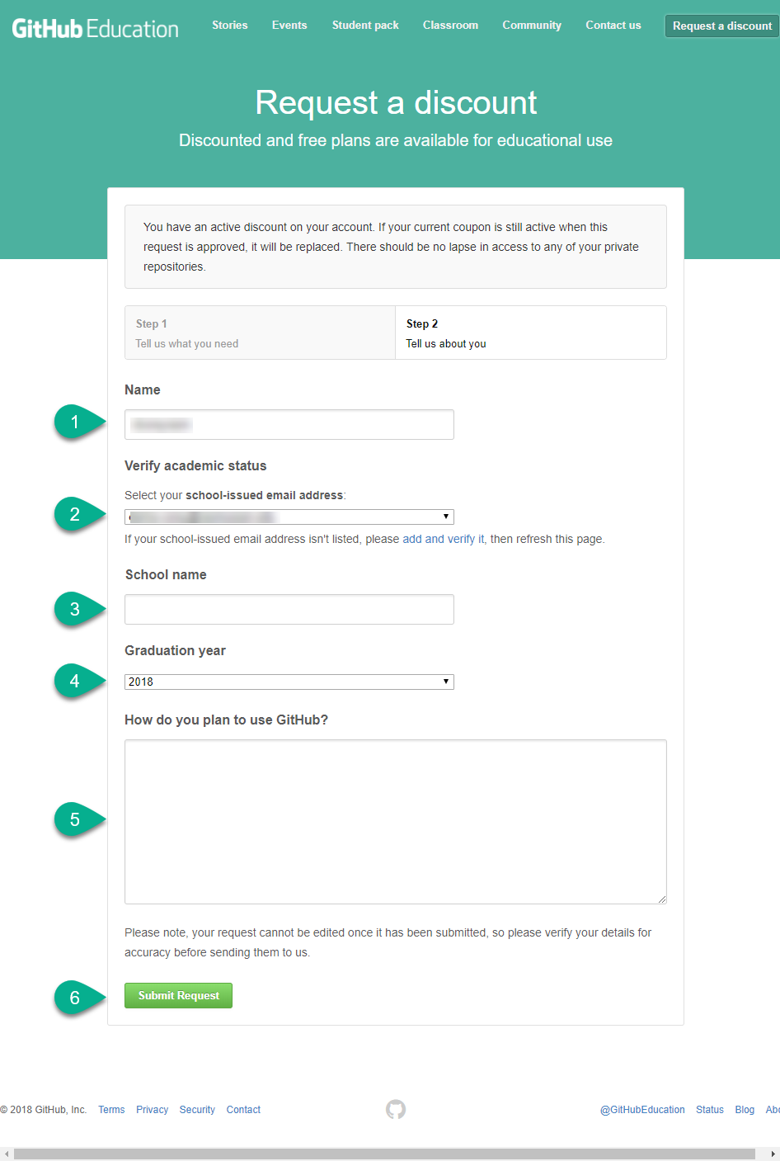

Return to your profile on GitHub.com and click to Create a New Repository:

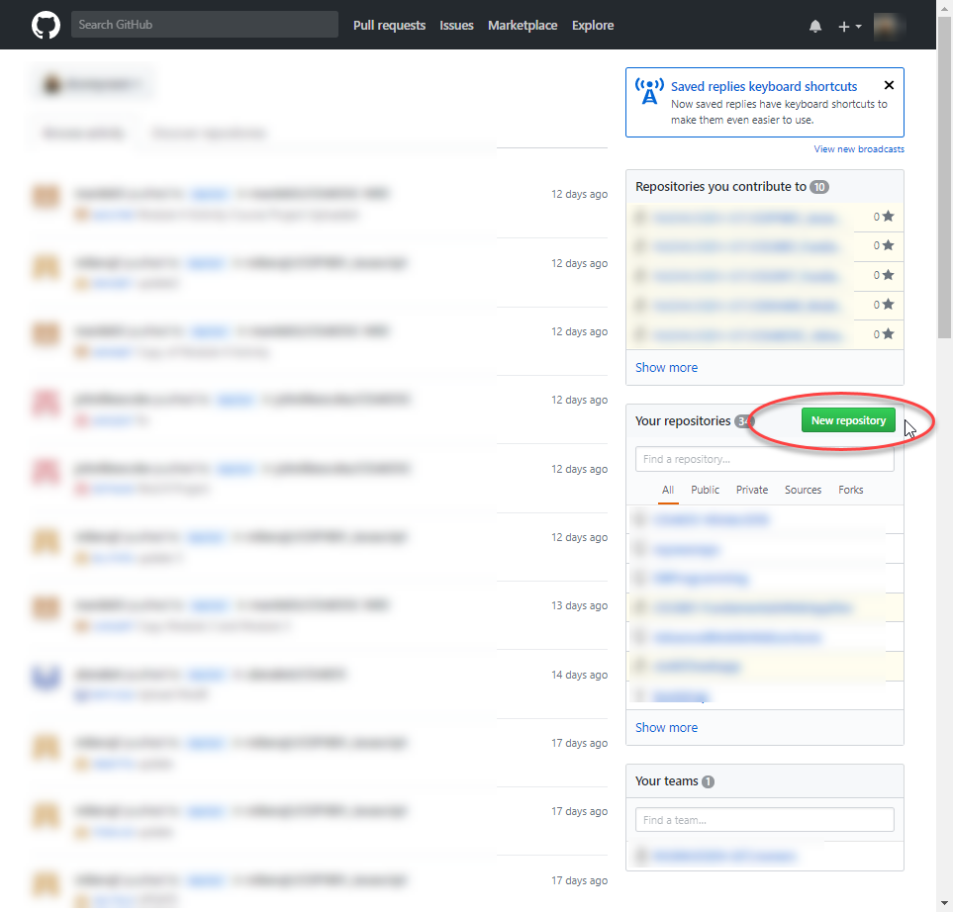

Give the repository the name such as the course title, “CIS3917_Distributed_Databases”. In the description, make sure it includes your first and last name. Your account should default to a public repository. Check off the option to initialize with a README. Click on Create repository.

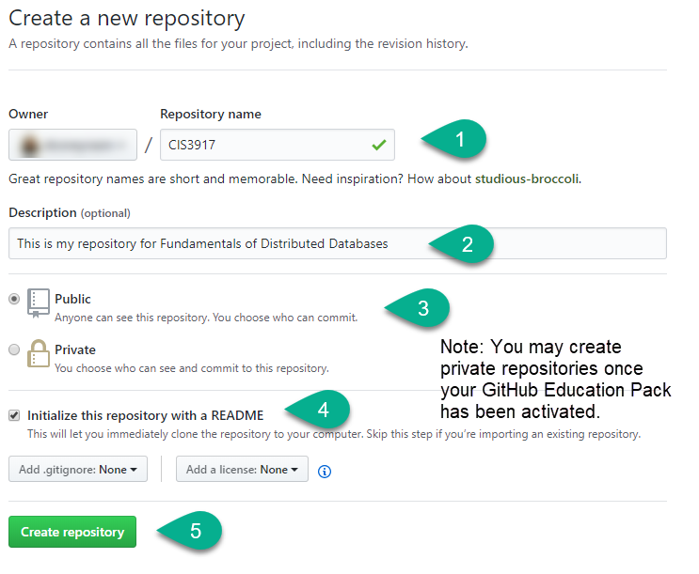

You’ll then see your repository created:

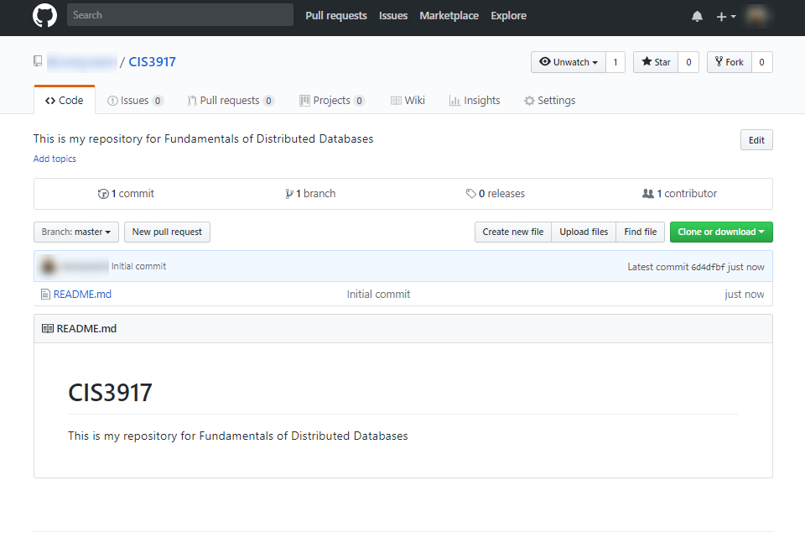

Using Atom to connect to GitHub

Click on Packages >> GitHub >> Toggle Git Tab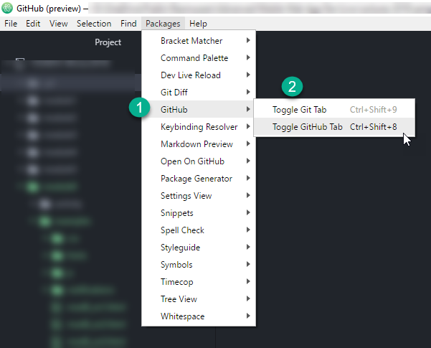

Click on the Git tab.

To push any changed files to your repository, click on Stage all. Then enter a message or description of your changes. Click on Commit. Once COMMIT is pressed, the staged files will vanish. Then click the arrows to select PUSH to push changes.

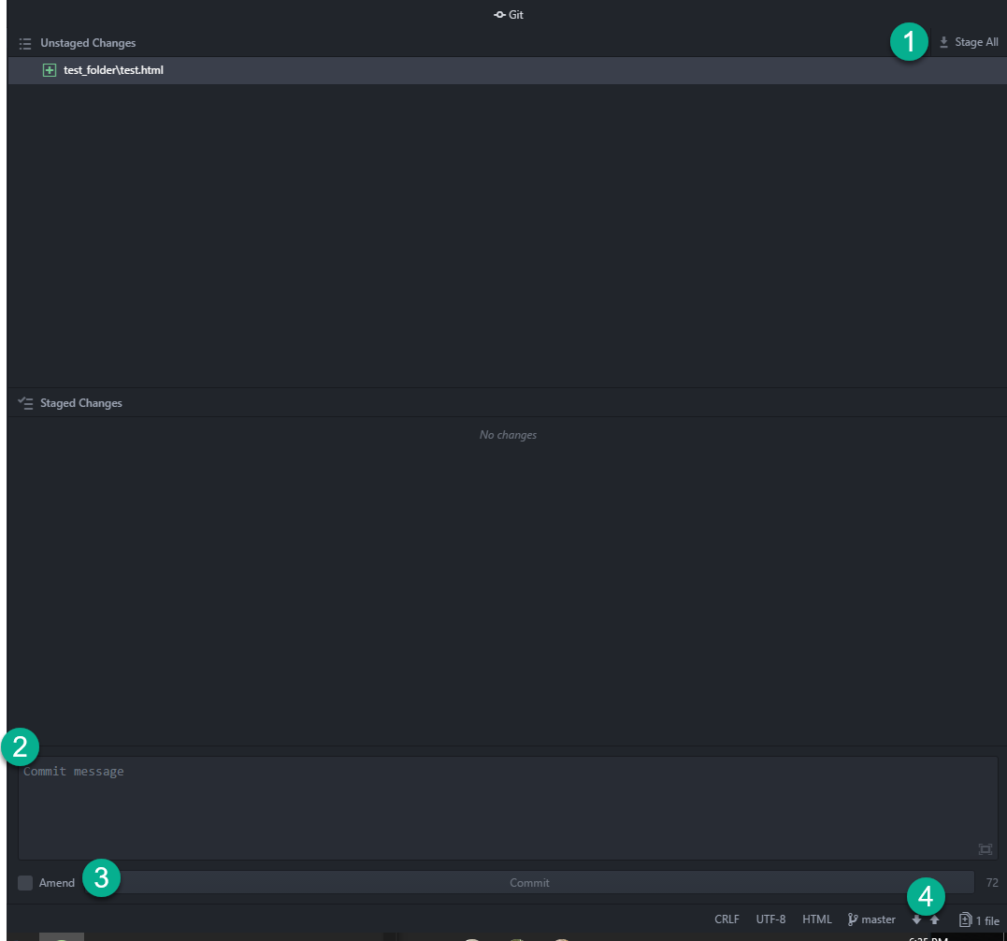

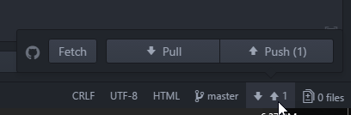

You may need to authenticate to GitHub:

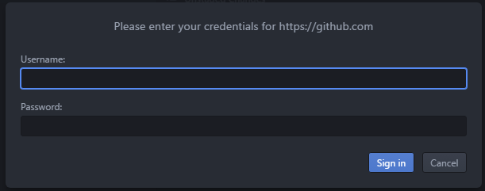

You should then see your pushed changes in your repository on GitHub.com.

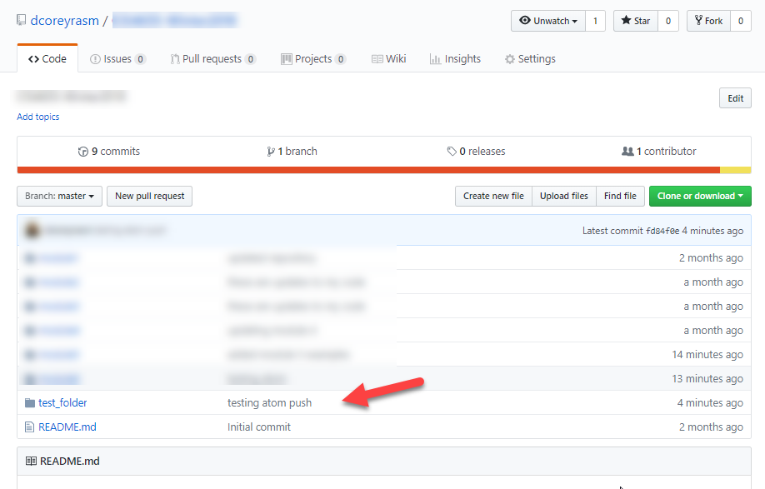

**Using GitHub Desktop**

If you prefer to use GitHub Desktop, download it here: <https://desktop.github.com/>

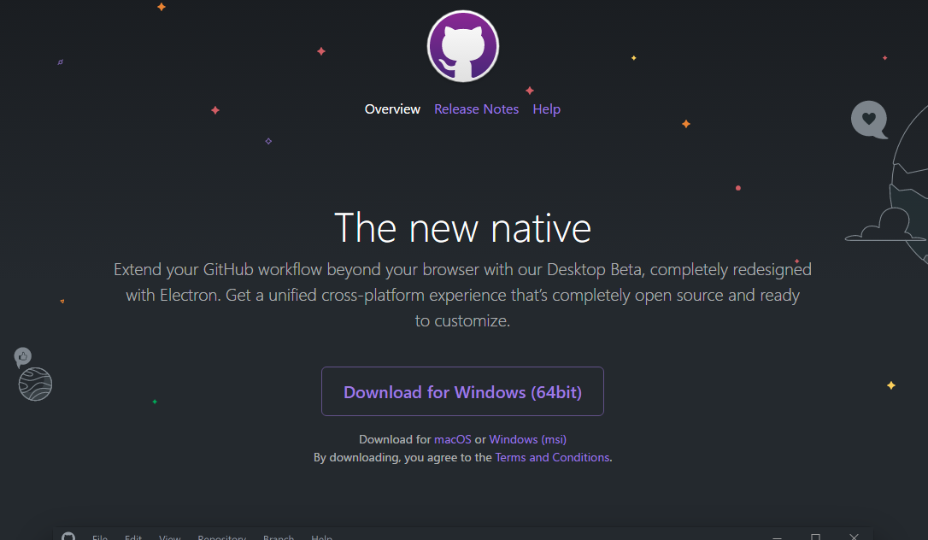

Install and configure the software to connect to your GitHub account. Instructions are available here: <https://help.github.com/desktop-beta/guides/getting-started-with-github-desktop/>

Clone your repository to your desktop

* Click on CLONE OR DOWNLOAD
* Select OPEN IN DESKTOP
* This will launch GitHub Desktop.
* It will confirm where you want to store your local copy. This should be the SAME FOLDER you use for FTP to your SOTD site, if SOTD is being used as a host. Click OK.

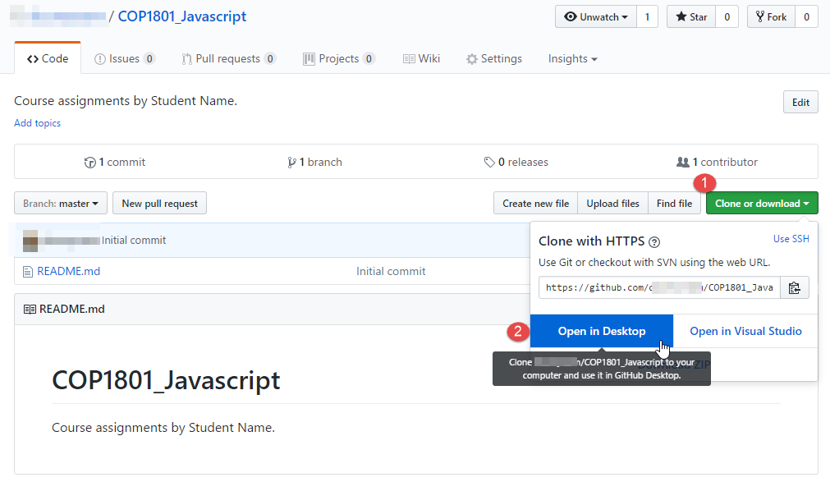

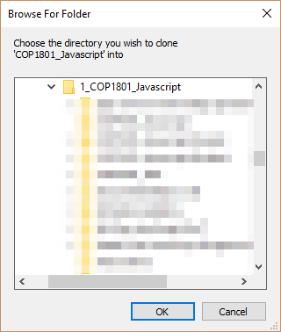

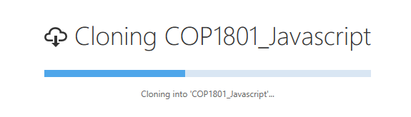

Open up the repository in GitHub desktop

* If you modify any files locally, you should see them listed as ‘Changes’
* Click on your repository
* You’ll see any modified or new files listed with checkmarks next to them.
* Enter a summary of your change and a description.
* Click on COMMIT TO MASTER

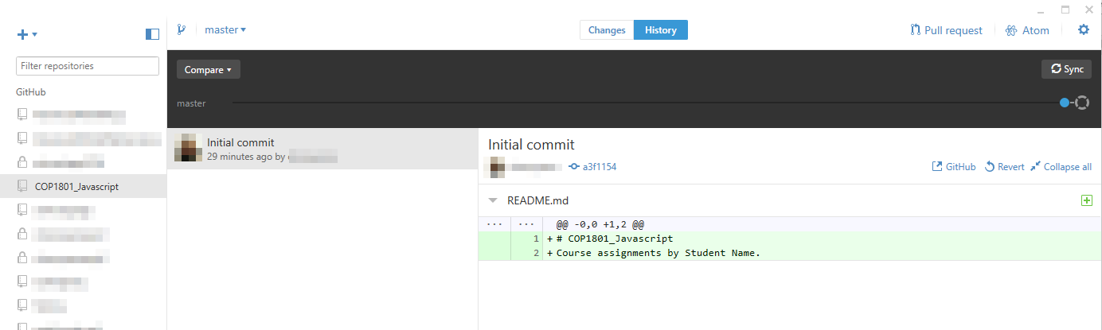

Open your folder on your local machine. It should now have a ‘.git’:

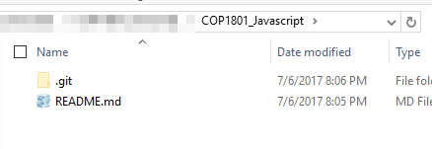

Create folders for each Module, using an underscore between the word, Module, and the module number. This will be important when it comes to uploading your folders to your SOTD host. You should not use spaces in your folder names.:

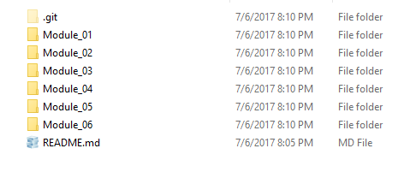

In each module folder, create 2 more folders, called ‘activity’ and ‘project’. Each assignment using any code will be placed in respective folders week to week.

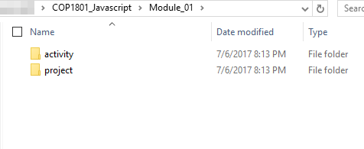

Creating a commit

* You’ll see a message across the lower left stating ‘Created commit’ plus your summary.
* Now click on SYNC in the upper right.
* This will push your changes or new files to your GitHub repository on GitHub.com.

For example, save a sample text file to the Module_01/activity folder:

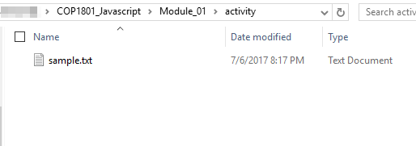

Return to GitHub desktop. Notice next to CHANGES, a dot appears indicating there has been a change.

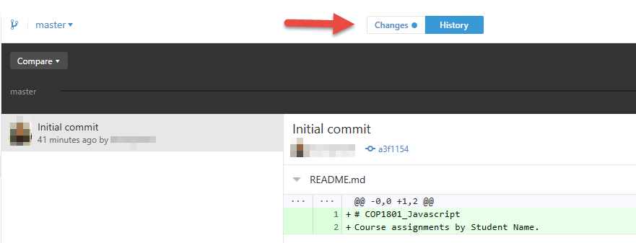

When you click on CHANGES, it lists any files that have been modified. When you click on the file, the right side of the window will list any modifications. In this case, the file is empty.

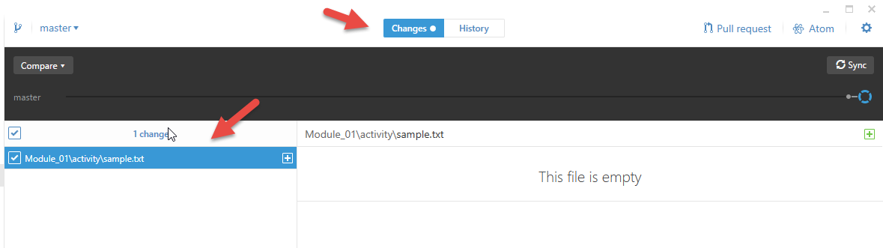

Type in a note regarding the commit, then click on Commit to Master:

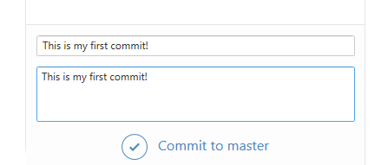

You’ll then see a message stating that you created a commit:



Now push your changes to your repository by clicking SYNC in the upper right hand corner. You’ll then see it syncing until it has copied all changes to your GitHub repository.

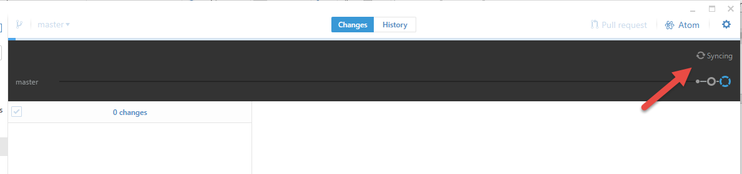

When you view your repository on GitHub.com, you should see your pushed changes.

